Application Form

6th International Symposium
of the International Geoscience Programme (IGCP) Project-589
(Kraków; 29 September – 5 October 2017)

(Please complete the attached form and return it as soon as possible, but not later than
May 15, 2017)

Name and Family Name ..................................................................................
Contact address ..........................................................................................
................................................................................................................
City, ZIP ....................................................................................................
Country .....................................................................................................
Telephone ..................................................................................................
FAX ..........................................................................................................
E-Mail ........................................................................................................

I will attend the Symposium yes no
I intend to give an oral presentation a poster
with the preliminary title: ...............................................................................
................................................................................................................
................................................................................................................

Demanded technical facilities (data projector, slide projector, overhead projector, others – .............................................................................................................)

I’m interested in the Post-Symposium field trip: yes no

Suggestions/Remarks .....................................................................................
................................................................................................................
................................................................................................................
................................................................................................................

................ ................................
date signature
-----------------------------------------------------------------------------
» Contact  Michał Krobicki  Polish Geological Institute  National Research Institute  Carpathian Branch  Skrzatów 1, 31-560 Kraków, POLAND  Phone: 048-12-2901397  Fax: 048-12-2901388  Mobile phone: 048-507070025  michal.krobicki@pgi.gov.pl | AGH University of Science and Technology  Faculty of Geology, Geophysics and Environmental Protection  Department of General Geology and Geotourism  al. Mickiewicza 30, 30-059 Kraków, POLAND  Phone: 048-12-6173148  Fax: 048-12-6332936  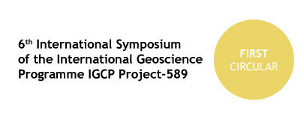Mobile phone: 048-507070025  krobicki@geol.agh.edu.pl

